# Tasks

## Arfah rizwan 54983

Task 1:

<?php

$a = 10;

$b = 25;

$c = 15;

$greatest = max($a, $b, $c);

echo "$greatest is the greatest.";

?>

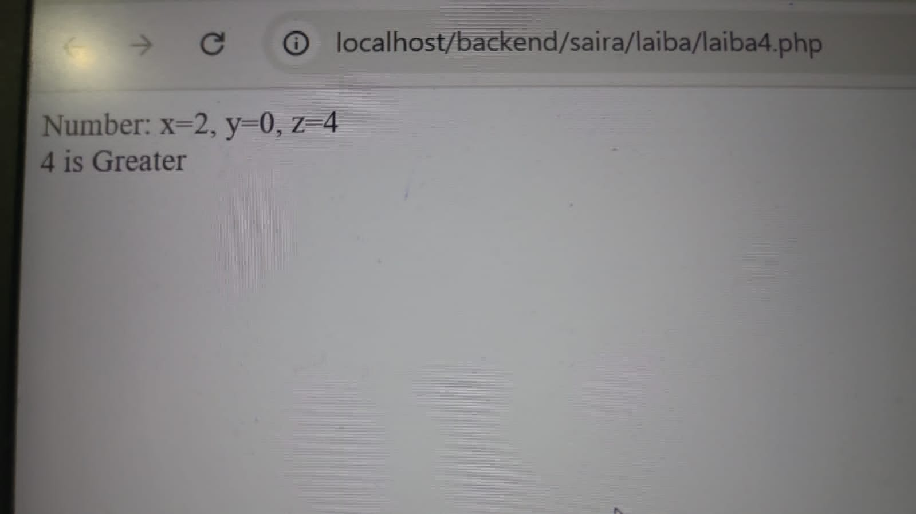

Task 2

<?php

$a = 5;

$b = 10;

echo "Before swap: a = $a, b = $b\n";

// Swapping

$temp = $a;

$a = $b;

$b = $temp;

echo "After swap: a = $a, b = $b\n";

?>

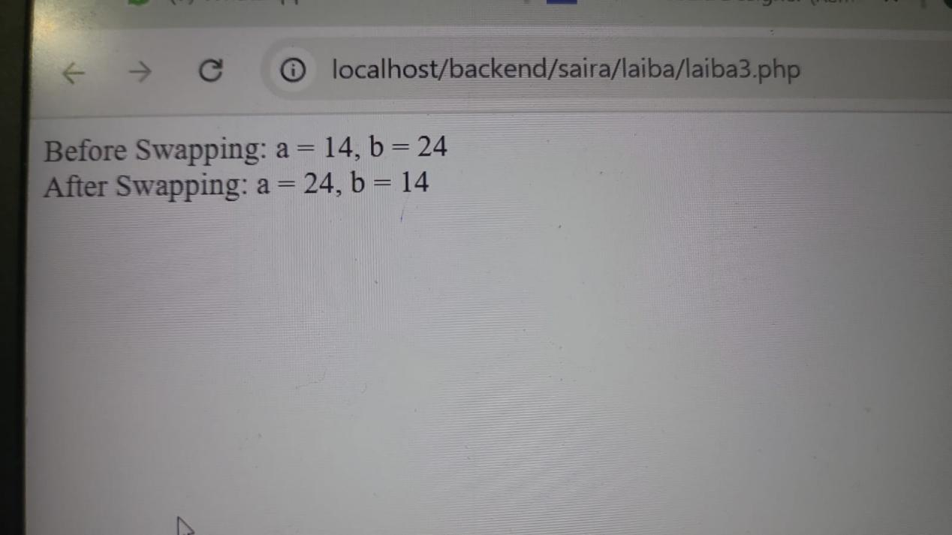

Task 3

<?php

$number = 7; // You can change this to any number

if ($number % 2 == 0) {

echo "$number is even.";

} else {

echo "$number is odd.";

}

?>

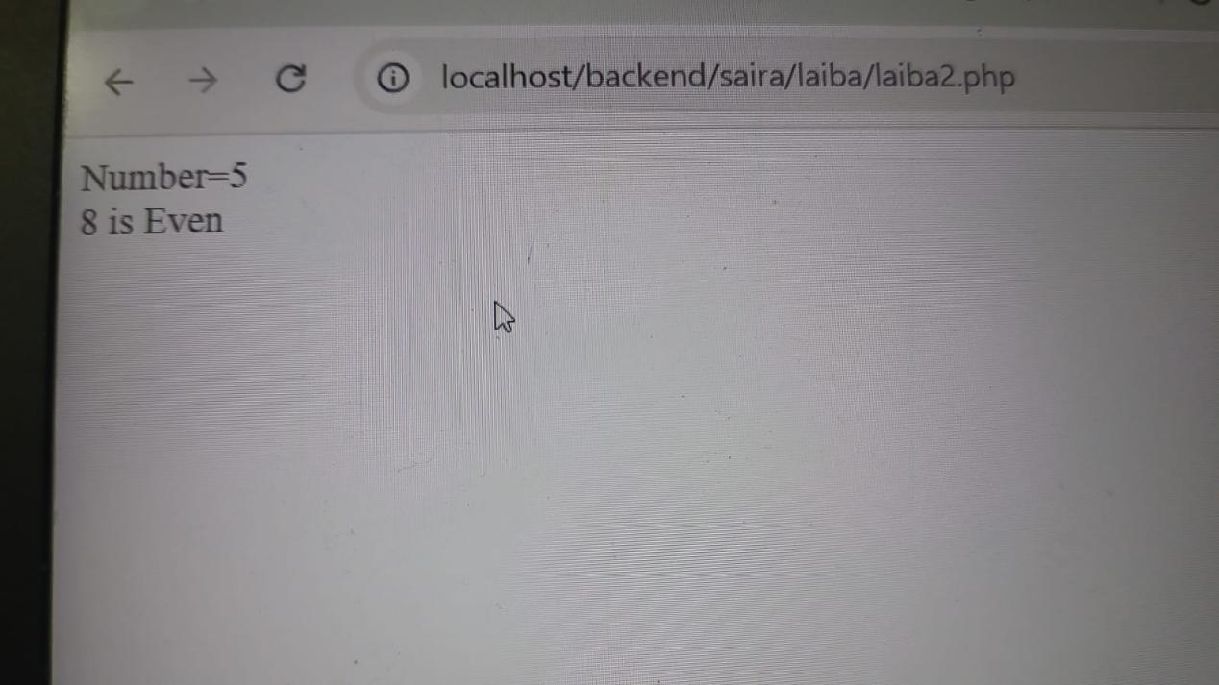

Task 4

<?php

$x=8;

$y=4;

echo "Addition" . "<br>";

echo $x+$y . "<br>";

echo "Subraction" . "<br>";

echo $x-$y . "<br>";

echo "Multiplication" . "<br>";

echo $x*$y . "<br>";

echo "Division" . "<br>";

echo $x%$y . "<br>";

?>

